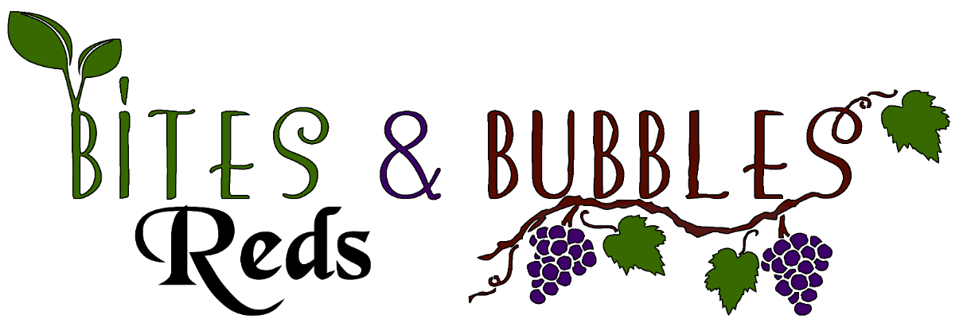
Red Wine Selections Bottle/Stem
Georges Duboeuf Beaujolais Nouveau Gamay, France 8
Diseño Malbec, Mendoza, Argentina 9
Llama Malbec, Mendoza, Argentina 2017 13
Layer Cake Malbec, Mendoza, Argentina 2016 13
Vistalba, Corte C, Malbec – Cabernet Sauvignon Blend, Mendoza, Argentina 15
Diseño Red Blend, Mendoza, Argentina 9
Laya, Bodegas Atalaya, Red Blend, Spain 12
Planeta, La Segreta Rosso, Red Blend, Sicily, Italy 12
Meeker Roller Coaster, Red Blend, Sonoma, California 11
Annabella 5, Red Blend, Napa, California 2017 15
Geyser Peak, Tectonic Red, Red Blend, Alexander Valley, California 2012 12
Evolution, Big Time Red Blend, Sokol Blosser, Willamette Valley 18
Neyers Vineyards, Sage Canyon, Red Blend, California 18
Juan Gil, Jumilla Red Wine, Monastrell, Murcia, Spain 18
Berton Vineyards, Petite Sirah, Metal Label, Austrailia 12
Ravenswood, Zinfandel, California 9
The Immortal Zin, Old Vine Zinfandel, Lodi California 18
Ravenswood Old Vine Zinfandel, Lodi California 18
Rombauer Vineyards, Zinfandel, Napa Valley California 35
Georges Dubœuf, Merlot, Wildflower, Pays d’Oc, France 2017 9
Charles Smith, Velvet Devil Merlot, Washington State 2016 9
Ravenswood Merlot, California 9
Meeker Handprint Merlot, Sonoma, California 2014 40

Red Wine Selections Bottle/Stem
Bodega Garzón, Cabernet Franc Reserva, Uruguay 2017 11
Georges Dubœuf, Cabernet Sauvignon, Wildflower, Pays d’Oc, France 2017 9
Grayson Cellars, Cabernet Sauvignon, Lot 10, California 2017 9
Peirano Estate, Cabernet Sauvignon, Lodi, California 2016 16
Aviary, Cabernet Sauvignon, California 2017 17
Joseph Carr, Cabernet Sauvignon, Napa, California 2016 24
Doña Paula, Cabernet Sauvignon, Estate Luján de Cuyo, Mendoza, Argentina 18
Napa Cellars, Cabernet Sauvignon, Napa, California 35
Turnbull, Cabernet Sauvignon, Napa Estate, California 55
Jordan, Cabernet Sauvignon, Sonoma, California 2014 60
Freemark Abbey, Cabernet Sauvignon, Sonoma, California 2014 45
Mt. Veeder Winery, Cabernet Sauvignon, Napa, California 2016 38
Ségla Margaux, Château Rauzan-Ségla, France 90
La Grivelière, Tete de Cuvée, Côtes du Rhône 2016 12
Aresti, Pinot Noir Riserva, Curico Valley, Chile 2018 10
Evolution, Pinot Noir, Sokol Blosser, Willamette Valley 20
La Crema, Pinot Noir, Monterey, California 2017 15
Soter Vineyards, North Valley Pinot Noir, Willamette Valley, Oregon 2017 36
Bravium, Pinot Noir, Andercon Valley, California 2016 35
Foppiano Vineyards, Pinot Noir, Russian River Valley, California 35
Bodegas Breton Criadores, Tempranillo, Rioja Crianza Loriñon, Spain 14
Alpha Box & Dice, Grenache Tarot McLaren Vale 2018 25
Shatter, Maury Grenache, Languedoc-Roussillon, France 2017 30
Villa di Campobell, Chianti, Tuscany, Italy 2017 16

