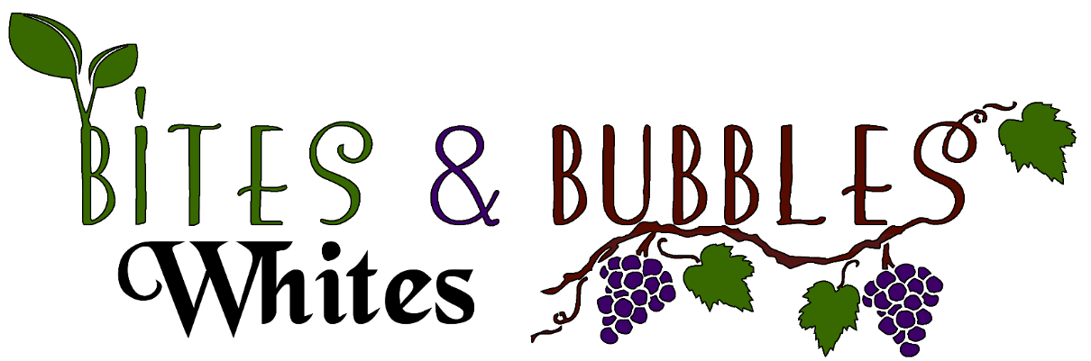
White Wines, Rose, Blush Bottle/ Stem
Mark West Chardonnay, California 8
Clos du Bois Chardonnay, California 8
Geyser Peak, Chardonnay, Alexander Valley, California 10
Sebastiani, Chardonnay, Sonoma North Coast, California 2017 12
La Crema, Chardonnay, Monterey, California 2017 15
Marques, Casa Concha, Chardonnay Chile 2014 12
Ferrari-Carano, Chardonnay, Sonoma, California 19
Foppiano Vineyards, Chardonnay, Russian River Valley, California 25
Domaine du Colombier, Chablis, Burgundy, France 2018 21
Antinori, Cervaro Castello della Sala, Chardonnay, Italy 20
Michel Lelu, Muscadet, Loire Valley, France 9
Vinosia, Beneventano Falanghina, Campania,Italy 10
The White Knight Viognier, Clarksburg, California 2017 10
Weingut Söllner, Toni, Grüner Veltliner, Austria 2018 12
Zacharias, Omikron, Roditis Moschofilero Blend, Peloponnese, Greece 10

White Wines, Rose, Blush Bottle/ Stem
Viña la Playa, La Playa Chardonnay Viognier Blend, Central Valley, Chile 9
Spine Road, White Blend, California 10
Bila-Haut, White Blend, Côtes du Roussillon, France 2017 10
Clos des Lunes, Lunes Blanche Bordeaux Blanc, Bordeaux, France 12
Kendall-Jackson Vintner’s Reserve, Rosé, California 9
Aime Roquesante, Côtes de Provence Rosé, France 2018 14
Charles, Smith, Kungfu Girl, Riesling, Washington State 2015 9
Clean Slate, Riesling, Mosel, Germany 2017 9
Montevina, Terra d’Oro Moscato, California 2018 9
Estancia Pinot Grigio, California 2018 9
Clos du Bois Pinot Grigio, California 2018 9
Mark West Pinot Grigio, California 2018 9
Benvolio, Pinot Grigio, Friuli-Venezia Giulia, Italy 9
Barone Fini, Valdadige Pinot Grigio, Italy 2018 9
Danzante, Pinot Grigio, Friuli-Venezia Giulia, Italy 10
Josh Cellars, Pinot Gris, Columbia, Washington State 2018 10
Lagar da Condesa, O Fillo Da Condesa Rias Baixas, Albariño, Spain 2018 9
Clos du Bois, Sauvignon Blanc, California 9
Mason Cellars, Sauvignon Blanc, Napa, California 2018 18
Trinchero, Mary’s Single Vineyard Sauvignon Blanc, Napa, California 2018 20
Domaine de Vaufuget, Vouvray Réserve, Chenin Blanc, Loire Valley, France 12

